Name ---------------------------------- stream -----------
MAKERERE COLLEGE SCHOOL
S 1. END OF TERM TWO EXAMINATION

MATHEMATICS

TIME: 1 HOUR

Instructions: Attempt all Questions.

1. Evaluate 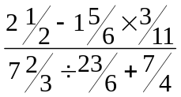.

2. Find the highest common factor (HCF) and lowest common multiple (LCM)
of 18, 45 and 42.

3. Convert 254_{six} to base five.

4. If a * b = 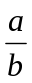 + 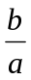 evaluate 2 * 3.

5. Solve for x in 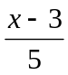 - 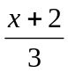 = 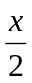 -

6. Express the recurring decimal 0.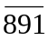 as a fraction in its simplest form.

7. A man is four times as old as his son. Six years ago he was ten times as old.
Find their present ages.

8. (a) Correct the numbers given to significant figures given:
(i) 139.48 (to 2 sf)
(ii) 2899. (to 3 sf).

(b) Write the numbers below is standard form.
(i) 23.6
(ii) 0.00485

- Write the following number to 2 decimal places. 93.2687.

9. Find the equation of the line passing through (-2, 3) and (1, 9)

10. On the same axes , on a graph paper, show by shading the unwanted regions the region which satisfies the inequalities x ≥ 1, y ≥ - 1 and x + y ≥ 5.
Calculate the area of the unshaded region.

END

